R Programming Assignment 2 Instructions – Week 3: Caching the Inverse of a Matrix
This second programming assignment will require you to write an R function that is able to cache potentially time-consuming computations. For example, taking the mean of a numeric vector is typically a fast operation. However, for a very long vector, it may take too long to compute the mean, especially if it has to be computed repeatedly (e.g. in a loop). If the contents of a vector are not changing, it may make sense to cache the value of the mean so that when we need it again, it can be looked up in the cache rather than recomputed. In this Programming Assignment you will take advantage of the scoping rules of the R language and how they can be manipulated to preserve state inside of an R object.

Example: Caching the Mean of a Vector
In this example we introduce the <<- operator which can be used to assign a value to an object in an environment that is different from the current environment. Below are two functions that are used to create a special object that stores a numeric vector and caches its mean.

The first function, makeVector creates a special "vector", which is really a list containing a function to
- set the value of the vector
- get the value of the vector
- set the value of the mean
- get the value of the mean
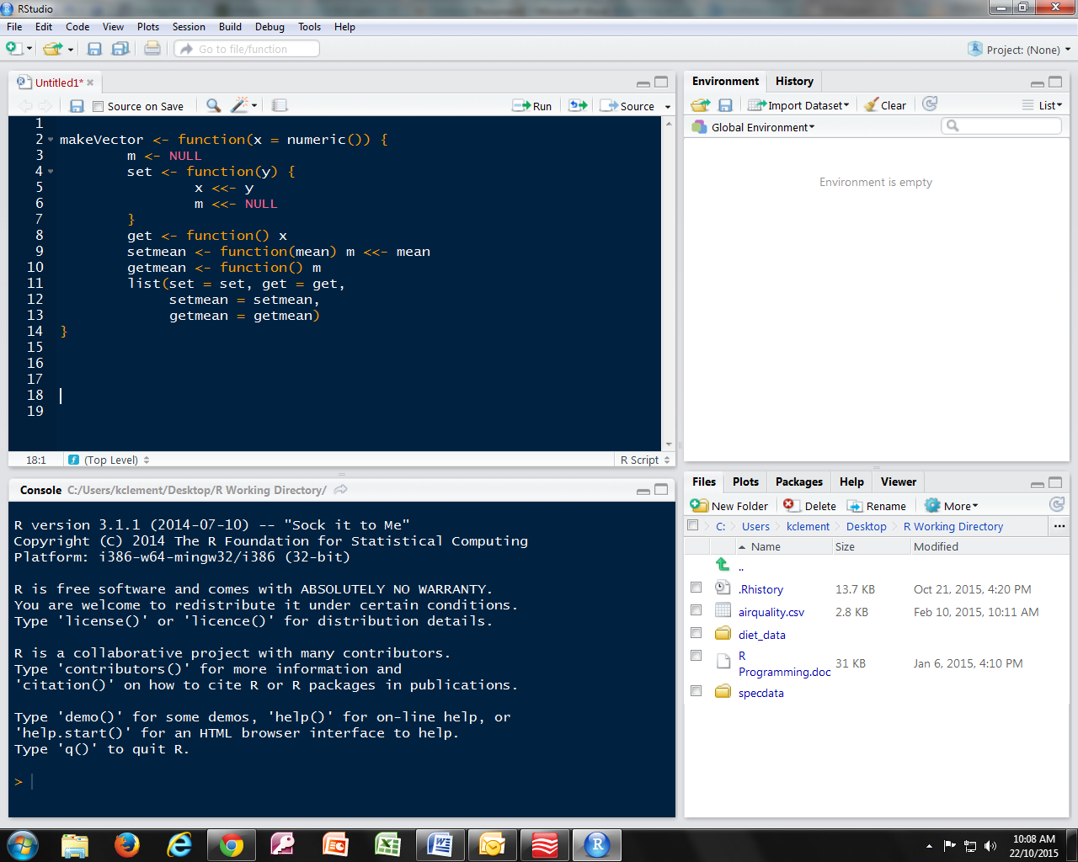

The following function calculates the mean of the special "vector" created with the above function. However, it first checks to see if the mean has already been calculated. If so, it gets the mean from the cache and skips the computation. Otherwise, it calculates the mean of the data and sets the value of the mean in the cache via the setmean function.
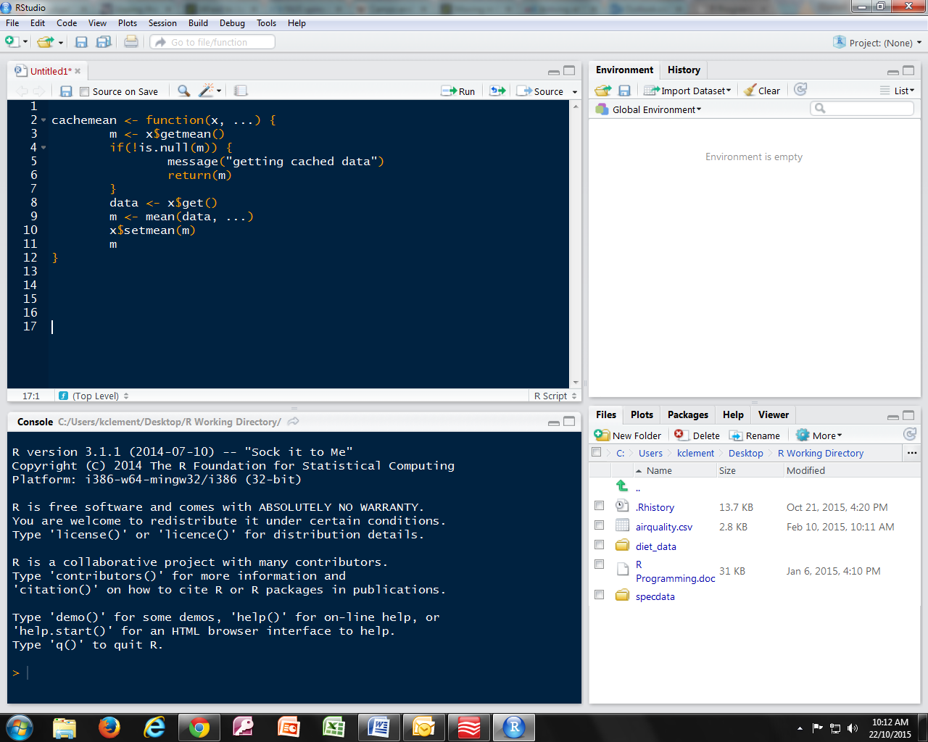
Additional explanation:

makeVector is a function that stores a list of functions (contains four functions): set, get, setmean, getmean.

1) set is a function that changes the vector x stored in the main function (makeVector).
This function is use when we want to change the value of vector x.

The expression x <<- y substitutes the vector x with y in the main function (makeVector).
If we use x <- y, it would have substitute the vector x with y only in the set function.

The expression m <<- NULL restores the mean m to null value, because the mean of the old vector is not needed anymore. The new mean needs to be recalculated via the cachemean function.

Example:
> a <- makeVector(c(5,1,3))
> a$get()
[1] 5 1 3

> a$set(c(7,4,1,2))
> a$get()
[1] 7 4 1 2

2) get is a function that returns vector x stored in the main function (makeVector). No input required.

Example:
> a <- makeVector(c(5,1,3))
> a$get()
[1] 5 1 3

3) setmean function is similar to set. It doesn’t calculate the mean, it simply stores the input value (variable m) in the main function (makeVector).

4) getmean function is similar to get. It simply returns the value of variable m set by setmean.

The value of setmean is supposed to be the mean of the vector x. However, it function in the same way like set and get, it simply stores a value (setmean) and return the value (getmean).

Example:
> a <- makeVector(c(1, 2, 3, 4)
> a$setmean(10)
> a$getmean()
[1] 10

Noticed that the returned value of 10 if not the mean of vector c(1, 2, 3, 4). It’s simply the value we stored using setmean, and we got it return using getmean.

We need a function list() to store the four functions in the makeVector function, so that when we assign makeVector to an object, the object has all the four functions.

Cachemean function 1) calculates the mean of the data and 2) set the value of the mean in the cache via the setmean function.

First, cachemean get the value of m from getmean.
Checks that it exists and is not NULL.
If it exists, it will returns a message “getting cached data” and return the value of m.
The function would end after returning m.

x$get() function gets vector x, which is stored in the main function (makeVector) and assigned it to data.
Calculation of the mean is performed and the result is assigned it to m.
x$setmean takes the input value (variable m) and stores it in the main function (makeVector).

Additional materials: On a function that stores a list of functions.
A simple example of a function that stores functions.

The plusFunctions stores two functions:
- plustwo() adds 2 to the given value.
- plusthree() adds 3 to the given value.

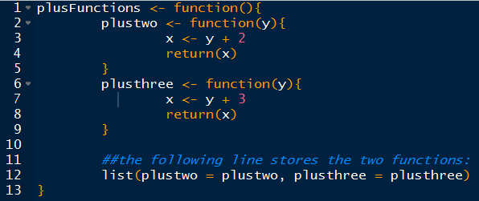

To use the plustwo or plusthree function stored in the main function (plusFunctions), we need to subset the particular function from the main function. To do this, we need the name of the main function + “$” + the name of the particular function with arguments.
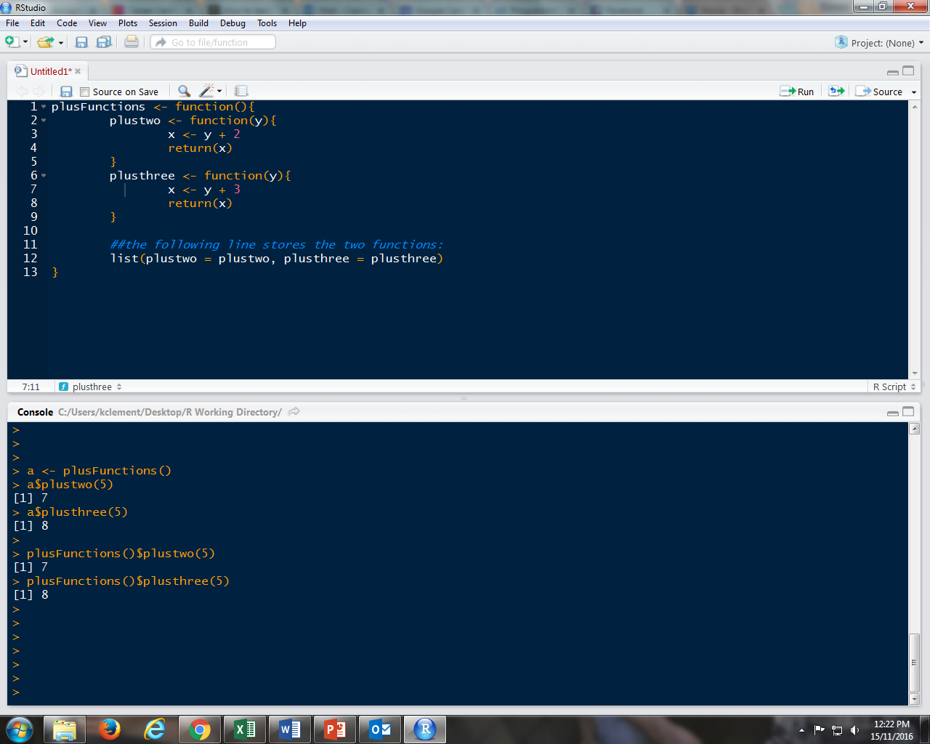

A neater code is to assign the plusFunctions to symbol a, then subset the particular function.

Assignment: Caching the Inverse of a Matrix
Matrix inversion is usually a costly computation and there may be some benefit to caching the inverse of a matrix rather than computing it repeatedly (there are also alternatives to matrix inversion that we will not discuss here). Your assignment is to write a pair of functions that cache the inverse of a matrix.
Write the following functions:
- makeCacheMatrix: This function creates a special "matrix" object that can cache its inverse.
- cacheSolve: This function computes the inverse of the special "matrix" returned by makeCacheMatrix above. If the inverse has already been calculated (and the matrix has not changed), then cacheSolve should retrieve the inverse from the cache.

Computing the inverse of a square matrix can be done with the solve function in R. For example, if X is a square invertible matrix, then solve(X) returns its inverse.
For this assignment, assume that the matrix supplied is always invertible.

In order to complete this assignment, you must do the following:
- Fork the GitHub repository containing the stub R files to create a copy under your own account. https://github.com/rdpeng/ProgrammingAssignment2.
- Clone your forked GitHub repository to your computer so that you can edit the files locally on your own machine.
- Edit the R file contained in the git repository and place your solution in that file (please do not rename the file).
- Commit your completed R file into YOUR git repository and push your git branch to the GitHub repository under your account.
- Submit to Coursera the URL to your GitHub repository that contains the completed R code for the assignment.

In addition to submitting the URL for your GitHub repository, you will need to submit the 40 character SHA-1 hash (as string of numbers from 0-9 and letters from a-f) that identifies the repository commit that contains the version of the files you want to submit. You can do this in GitHub by doing the following:
- Going to your GitHub repository web page for this assignment
- Click on the “?? commits” link where ?? is the number of commits you have in the repository. For example, if you made a total of 10 commits to this repository, the link should say “10 commits”.
- You will see a list of commits that you have made to this repository. The most recent commit is at the very top. If this represents the version of the files you want to submit, then just click the “copy to clipboard” button on the right hand side that should appear when you hover over the SHA-1 hash. Paste this SHA-1 hash into the course web site when you submit your assignment. If you don't want to use the most recent commit, then go down and find the commit you want and copy the SHA-1 hash.

A valid submission will look something like (this is just an example!)
https://github.com/rdpeng/ProgrammingAssignment2
7c376cc5447f11537f8740af8e07d6facc3d9645

